# Activity: Optimizing the columns and Auto date/time

# **Introduction**

You’ve already gained knowledge of the different ways to optimize the data model in a Microsoft Power BI report. You have been shown techniques to optimize columns and metadata and how to use the Auto date/time feature to the best advantage.

In this exercise, you will apply this knowledge by taking the following series of actions to optimize a data model:

* Identify and remove unnecessary columns.
* Categorize the data.
* Adjust data types for memory efficiency.
* Disable the Auto date/time feature when it’s not beneficial.

## **Case Study**

An Adventure Works Microsoft Power BI report is running slowly. You have been asked to make changes to improve the report's performance. The report is based on a large dataset that contains a large amount of transactional sales data. You will implement several changes to optimize the data model, which will help generate a fast, efficient, and impactful Power BI report.

Optimizing columns and the Auto date/time feature is about ensuring that each piece of data, each column, and each feature is functioning as efficiently as possible, and contributing to the smooth, swift execution of the report.

## **Step 1: Download and open the report**

1. Download the *AdventureWorksSales.pbix* Power BI Desktop report file.
2. Open Microsoft Power BI desktop. Choose the File tab in the ribbon area and then Open report from the sidebar menu.

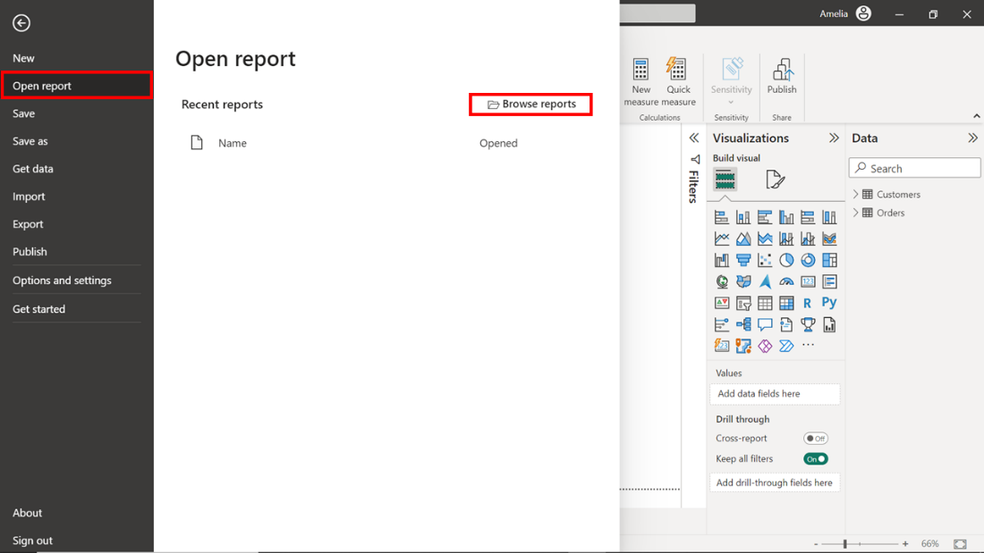

1. Select Browse reports and then navigate to the saved location of the AdventureWorksSales.pbix report on your system. Select the report and select Open to load it.

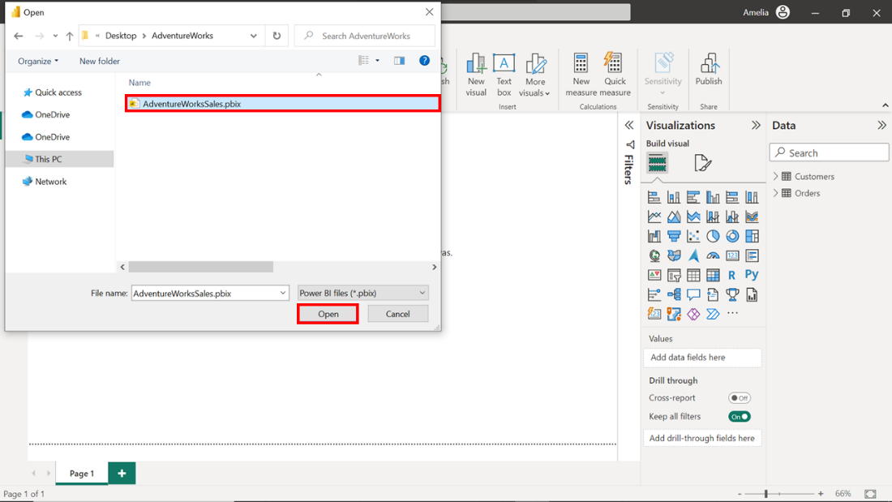

## **Step 2: Remove Unnecessary Columns**

Redundant data can slow down the performance of a data model. You can create a faster, more efficient model by removing redundant data. In this current model, the Payment Method column is not a contributing value and should be deleted. Let’s explore the steps to complete this action.

1. Select the Data view icon to inspect your tables and columns at a granular level. This helps you to understand your model’s shape and structure before you optimize it.

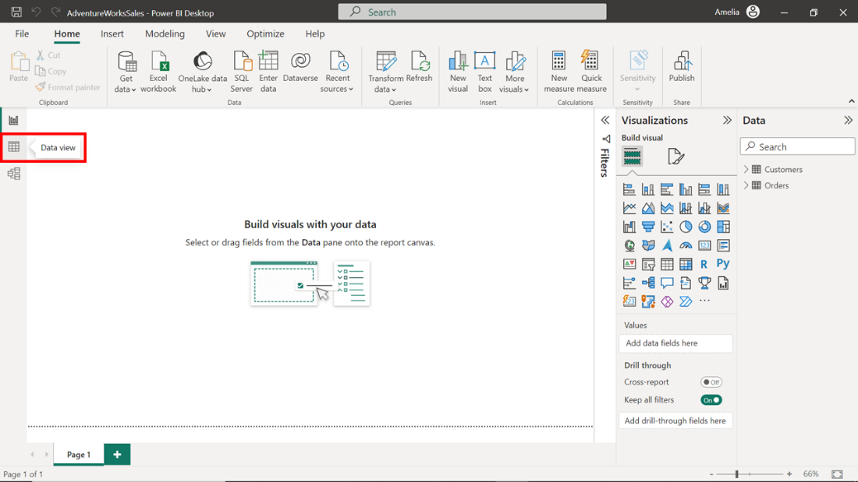

1. Expand the Orders table in the Data pane on the right-hand side to display the columns itcontains.

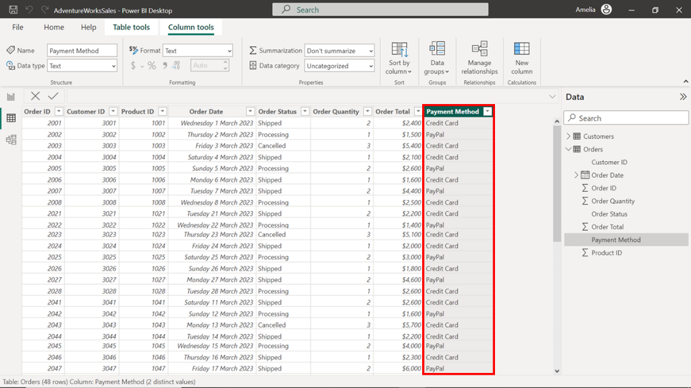

1. Right-click on the Payment Method column header to open the context menu and select Delete. This action declutters your data model’s structure and helps it to perform better.

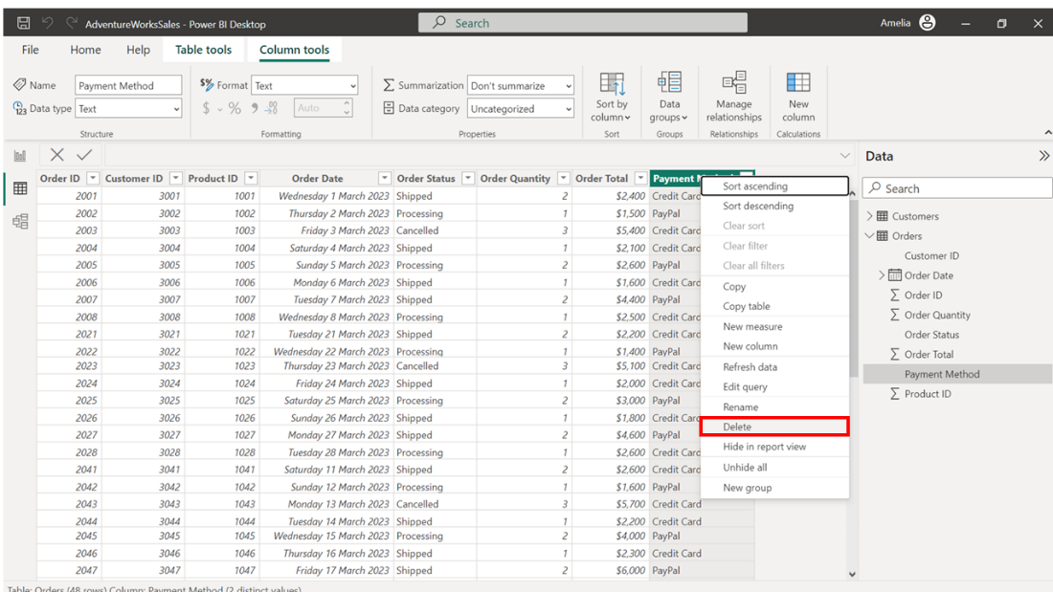

## **Step 3: Categorize the columns**

With the unnecessary column removed from the Orders table, you can switch focus to the Customers table. If the data in this table is categorized correctly, Power BI can understand it better and offer more relevant features and insights.

1. Select the Location column in the Customers table. Select the Column tools tab in the ribbon area at the top of the screen.

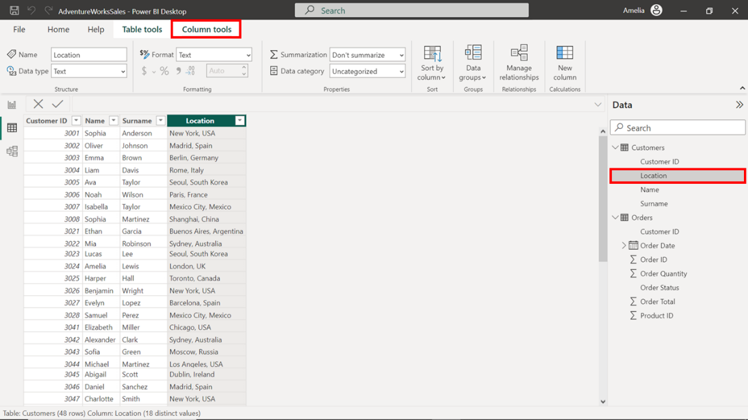

1. Select the Data category dropdown to open the dropdown menu. It contains categories such as City, Country, Image URL, and more.

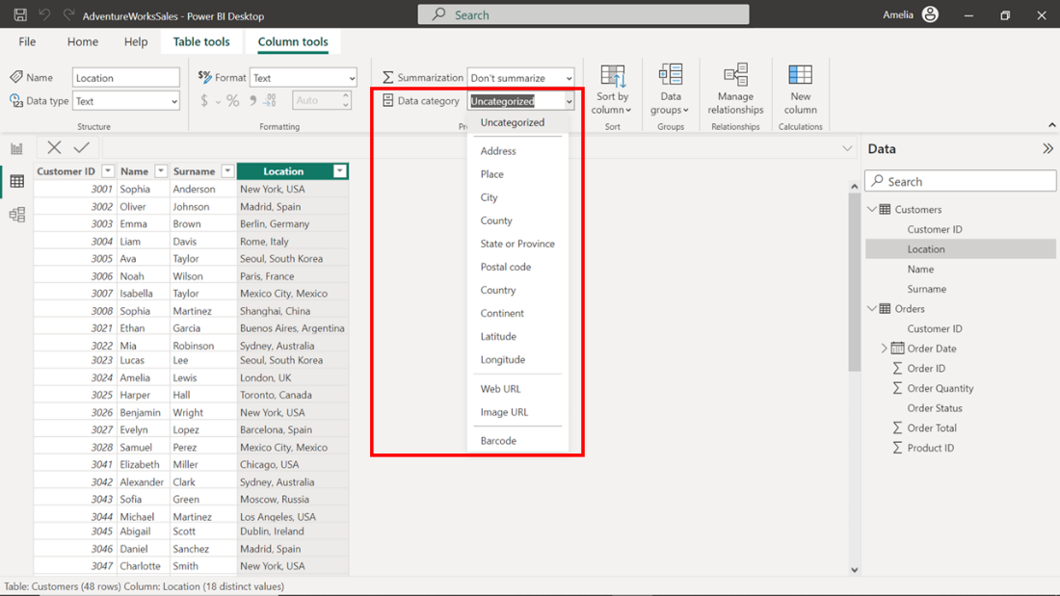

1. Select the City category as this best represents the content for the Location column.

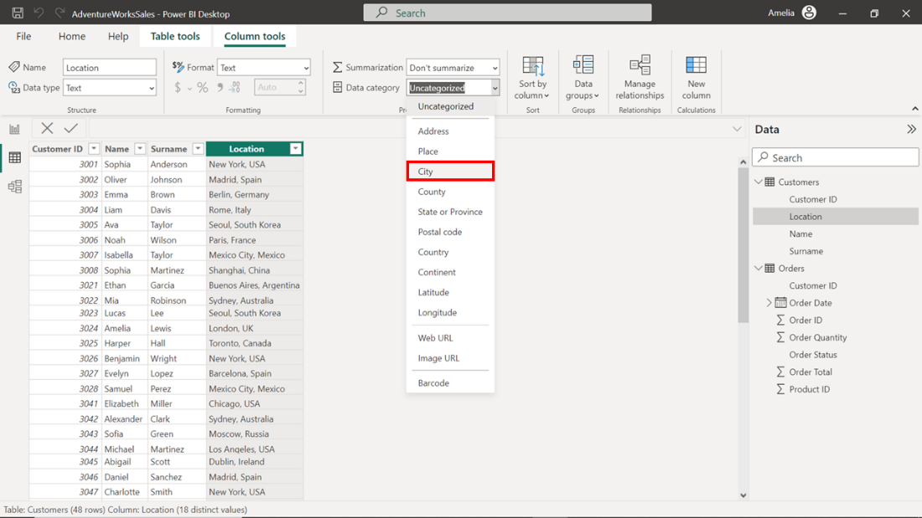

## **Step 4: Optimize the column data types**

The next step to optimize your data model involves adjusting the data types assigned to your columns in the Orders table. Power BI takes a “best-guess” approach to assign data types to each column when importing data. However, these automatic assumptions may not always align with memory efficiency. So, you might need to reassign data types as follows.

1. The Order Quantity column contains whole numbers, but the data type is labeled as Text, which would consume more memory than necessary.

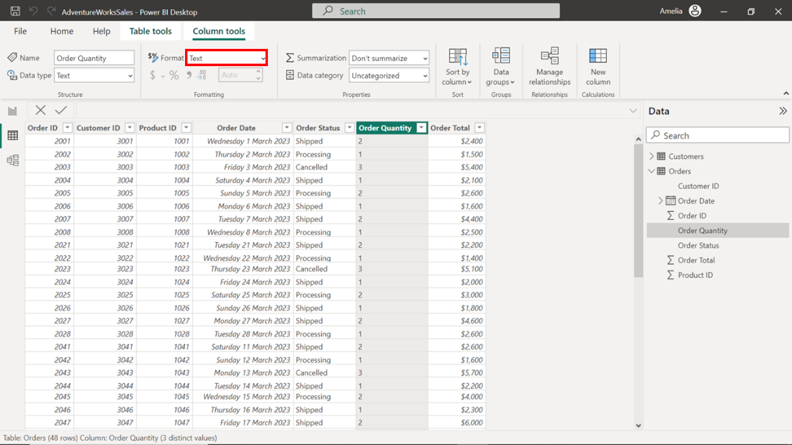

1. Select the Order Quantity column. Switch to the Column tools tab in the ribbon area and select the Data type dropdown. A drop-down menu opens, which displays the data types.

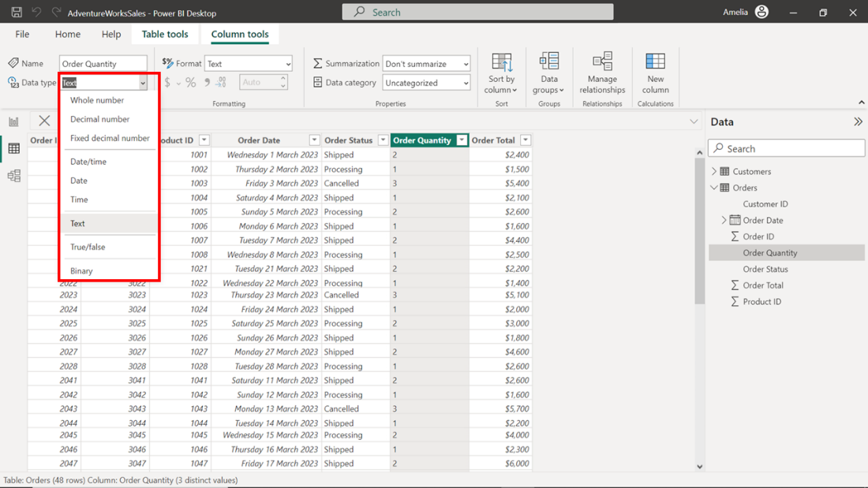

1. Choose Whole Number from the dropdown list. This is the appropriate type for the Order Quantity column. With every data type correction, you're improving the performance of the data model.

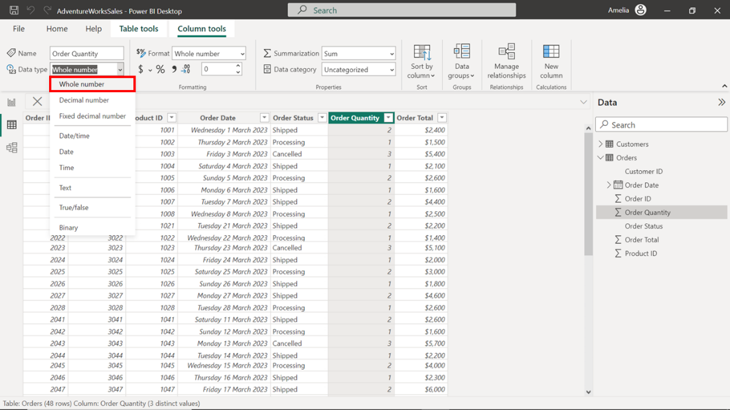

## **Step 5: Disable the Auto Date/Time feature**

You have now optimized your Power BI data model. However, one more feature needs your attention: the Auto Date/Time feature in Power BI. This box is checked by default, which means the feature is currently enabled. Power BI automatically generates hidden date tables whenever you introduce a field with a Date or Date/Time data type into your data model. This can cause slowdowns with large datasets. So let’s disable the feature.

1. Select the File tab in the ribbon area. In the sidebar menu, select Options and settings, and then Options in the submenu.

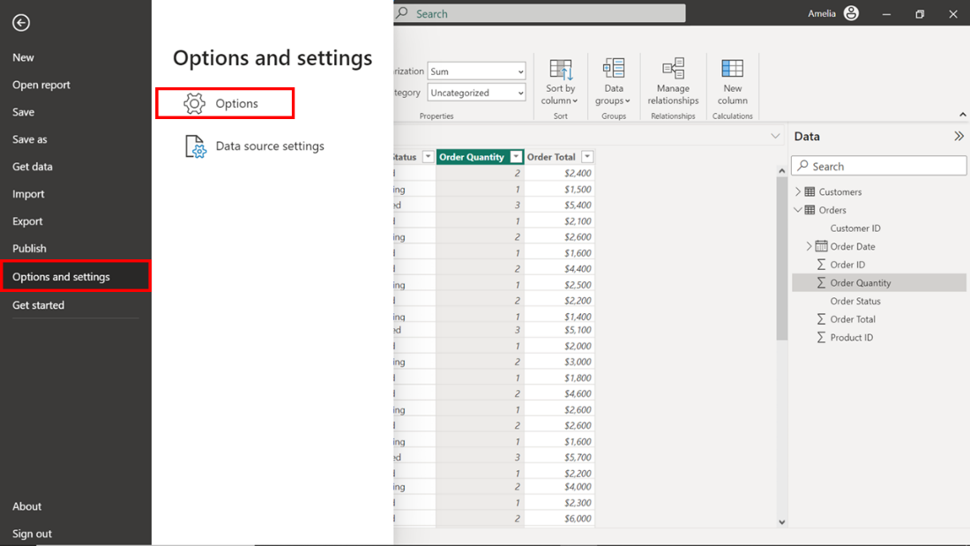

1. The Options window appears with the Global options choices shown by default. In the panel on the left, select Data Load from the Current file section.

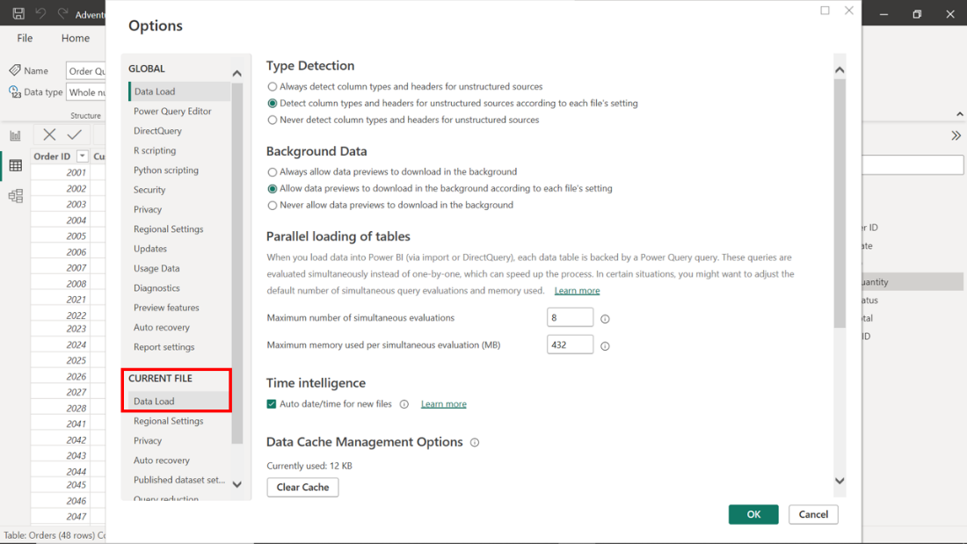

1. Identify the Auto date/time checkbox in the Data Load options. The box is checked by default. Uncheck this box to disable the current file's Auto date/time feature. Then select OK to apply the changes.

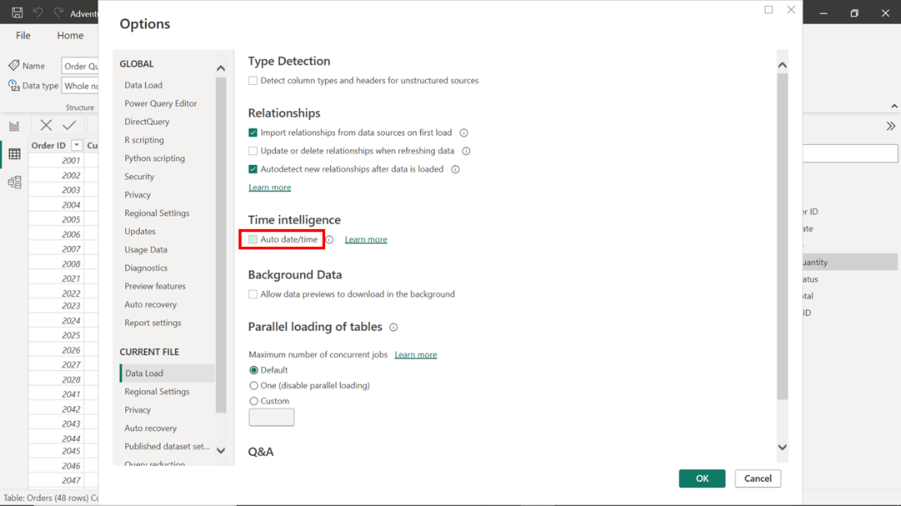

# **Conclusion**

You've optimized your data model by decluttering your data, categorizing it properly, assigning accurate data types, and disabling the Auto Date/Time feature. All these steps contribute to the overall performance and speed of your report.